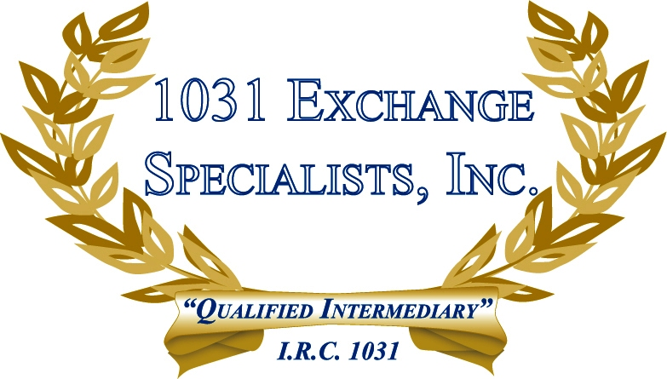

1031 CONTRACT LANGUAGE: The inclusion of 1031 language in the Agreement of Sale satisfies the "notice" requirement of a 1031 EXCHANGE. Let us know if you need sample language.

For additional information, please call or email us at:
Local: 609-398-1031 • Toll free: 877-513-1031 info@1031ESI.com

