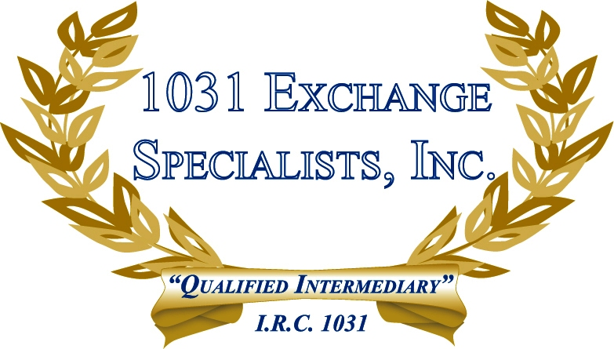

A 1031 EXCHANGE IS FEDERAL LAW: A 1031 Exchange is a federal law available in all 50 states, the District of Columbia and some U.S. territories outside the United States. Most state laws have a provision to follow the federal tax law, with some exceptions.

For additional information, please call or email us at:
Local: 609-398-1031 • Toll free: 877-513-1031 info@1031ESI.com

