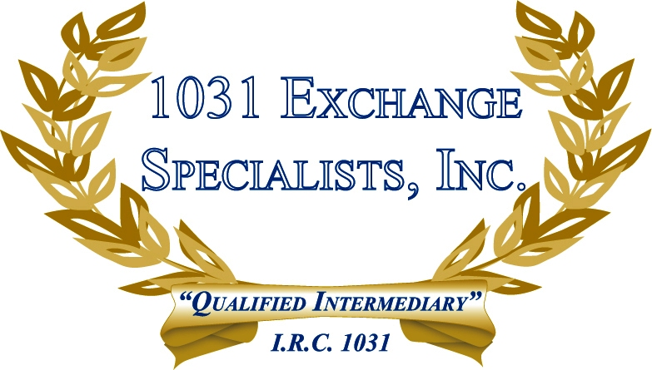

BUILD TO SUIT EXCHANGE: A "Build To Suit" 1031 EXCHANGE is beneficial to the taxpayer when the cost of improvements are needed to bring the value of the replacement property closer to the value of the relinquished property.

For additional information, please call or email us at:
Local: 609-398-1031 • Toll free: 877-513-1031 info@1031ESI.com

