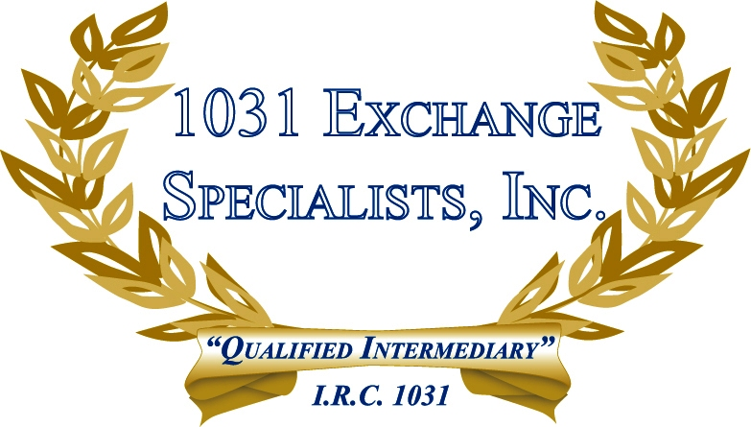

BUYING PROPERTY OF GREATER VALUE: The general concept of a 1031 EXCHANGE is to purchase a replacement property of equal or greater value than the relinquished property, whereby the purchase should be made with equal debt & equity and any excess value can be made with any combination of debt and cash. The taxpayer also has the option of reducing debt on the entire transaction by adding cash.

For additional information, please call or email us at:
Local: 609-398-1031 • Toll free: 877-513-1031 info@1031ESI.com

