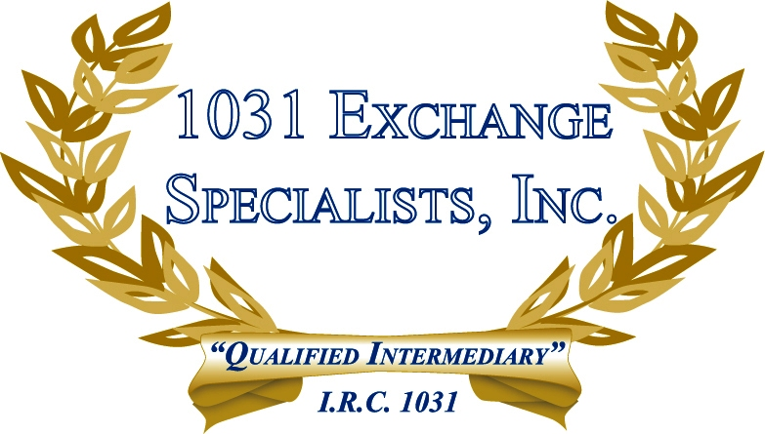

CLAWBACK PROVISION: A 1031 EXCHANGE of properties in different states may be subject to a "clawback" provision, whereby an exchange originating in CA, MA, MT or OR and replaced in another state will be subject to tax in the originating state upon subsequent sale in the replacement state. There is potential for double taxation upon sale if the replacement state also has a tax.

For additional information, please call or email us at:
Local: 609-398-1031 • Toll free: 877-513-1031 info@1031ESI.com

