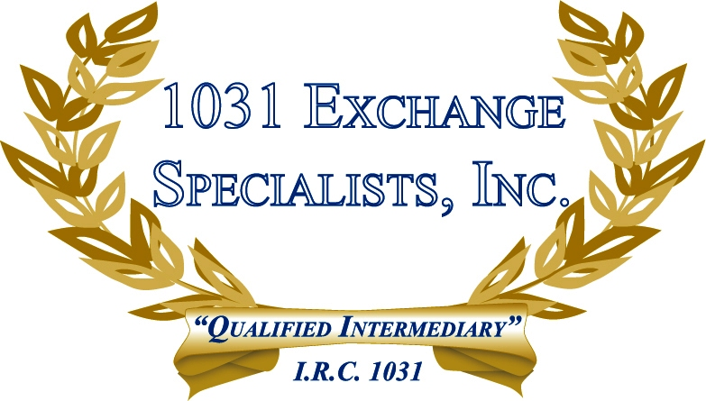

CONSERVATION EASEMENTS: Conservation Easements and Forestry Preserves, popular especially in NJ, place a restriction on the owner's deed and the proceeds received are generally fully taxable unless the owner utilizes a 1031 EXCHANGE to acquire another property, as the deed restriction is "like-kind" to the transfer of a fee simple interest for 1031 purposes.

For additional information, please call or email us at:
Local: 609-398-1031 • Toll free: 877-513-1031 info@1031ESI.com

