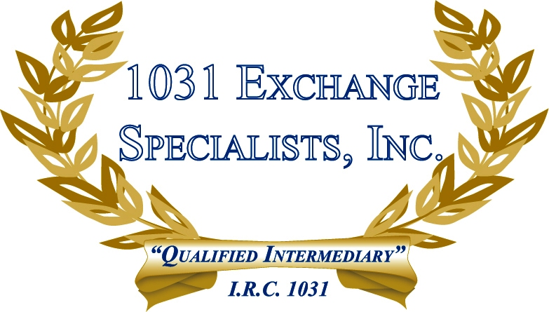

CURRENT 1031 ENVIRONMENT: Our current and past clients are taking advantage of the real estate bargains throughout the U.S. In many instances, clients are replacing their current property with multiple properties aggregating to the same value. In other instances, clients are purchasing replacement properties of lesser value and either keeping some of the cash or reducing their overall debt and paying some tax on the transaction. Most have found that although their existing property may have declined in value, the deferred gain in the current property and the available bargains on newer properties make a 1031 Exchange financially wise once again.

For additional information, please call or email us at:
Local: 609-398-1031 • Toll free: 877-513-1031 info@1031ESI.com

