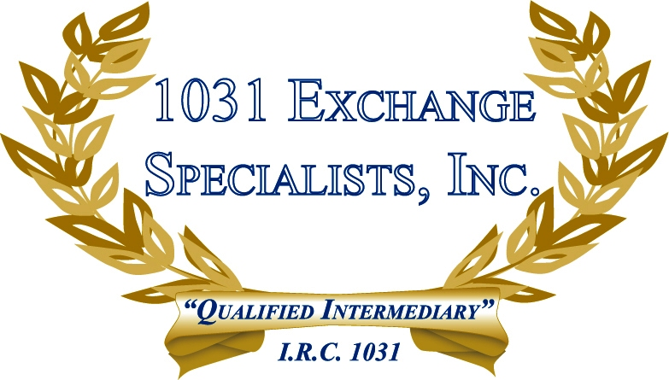

IDENTIFYING DEBT ON INVESTMENT PROPERTY: Securing debt on investment property with the equity in a principal residence is not the best financial strategy, however, if identifiable, it can be satisfied upon sale of the investment property with 1031 EXCHANGE proceeds.

For additional information, please call or email us at:
Local: 609-398-1031 • Toll free: 877-513-1031 info@1031ESI.com

