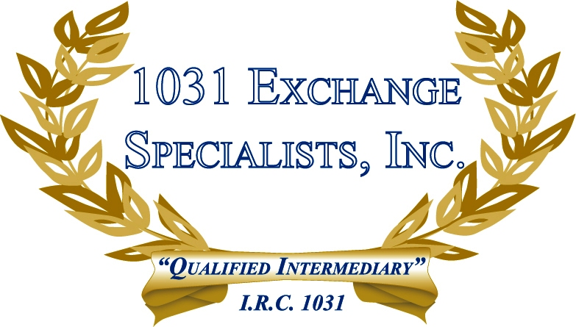

DEBT SECURED ON OTHER PROPERTY: Occasionally, a taxpayer will purchase investment property with debt secured by other property, or perhaps an umbrella mortgage. When selling an investment property in a 1031 EXCHANGE, can the 1031 proceeds be used to partially or totally satisfy debt secured by other properties? The answer is "sometimes yes". Call us.

For additional information, please call or email us at:
Local: 609-398-1031 • Toll free: 877-513-1031 info@1031ESI.com

