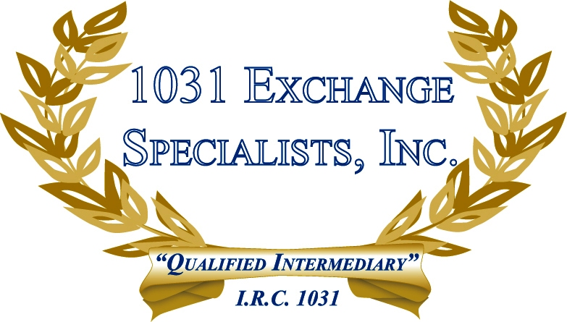

DEPRECIATION METHODS: Property acquired in a 1031 EXCHANGE can be depreciated under 2 different methodologies. A continuation of depreciation on the old basis and the application of the current depreciation method on the incremental new basis, Or, the combination of old and new basis depreciated under the current depreciation method.

For additional information, please call or email us at:
Local: 609-398-1031 • Toll free: 877-513-1031 info@1031ESI.com

