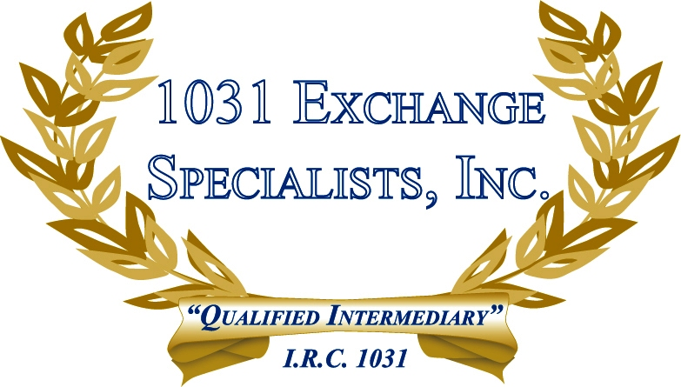

DIVISION OF PROPERTY OWNERSHIP: Purchasing property of lesser value in a 1031 EXCHANGE may not save tax dollars if the property being purchased is less than the tax basis of the property given up. However, to maximize tax savings, a division of the property(s) being sold by ownership or deed into smaller components may afford the taxpayer partial tax savings.

For additional information, please call or email us at:
Local: 609-398-1031 • Toll free: 877-513-1031 info@1031ESI.com

