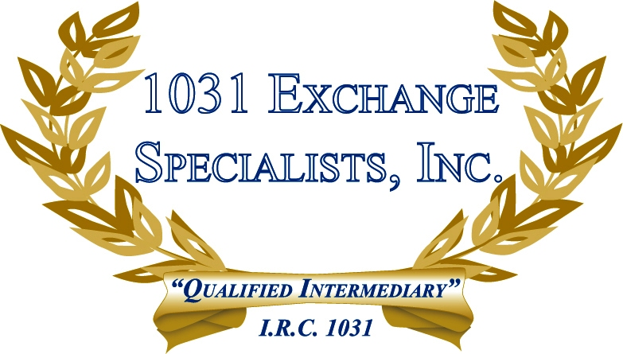

DOWNSIZE AND SAVE TAX DOLLARS: An Investor who has depreciated a property or has received a property as a gift can downsize their investment in a new property and still save tax dollars with a 1031 EXCHANGE.

For additional information, please call or email us at:
Local: 609-398-1031 • Toll free: 877-513-1031 info@1031ESI.com

