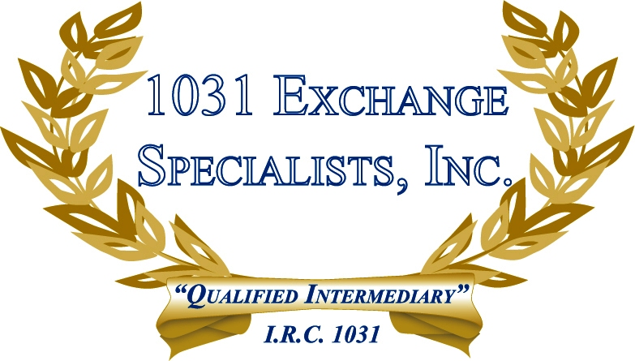

GIFTING REPLACEMENT PROPERTY: Gifting replacement property acquired in a 1031 EXCHANGE to others may disqualify the exchange if the intentions of the Donor are made known prior to or at the time of the exchange. Gift intentions made known after the acquisition of replacement property result in more successful exchanges.

For additional information, please call or email us at:
Local: 609-398-1031 • Toll free: 877-513-1031 info@1031ESI.com

