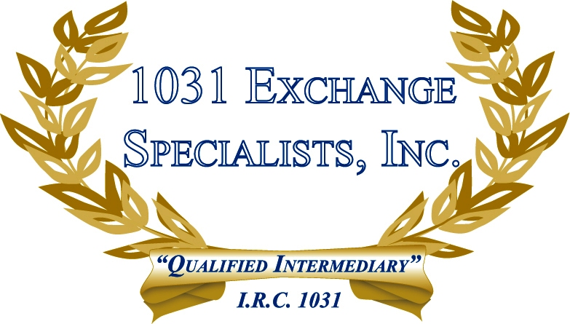

HOLDING PERIOD: A property acquired in a 1031 EXCHANGE acquires the holding period of the property given up. Therefore, if the new (replacement) property is disposed of in 1 year or less, it may still receive long term capital gains treatment and rates providing the combination of the old (relinquished) and new (replacement) property's holding periods are more than 1 year.

For additional information, please call or email us at:
Local: 609-398-1031 • Toll free: 877-513-1031 info@1031ESI.com

