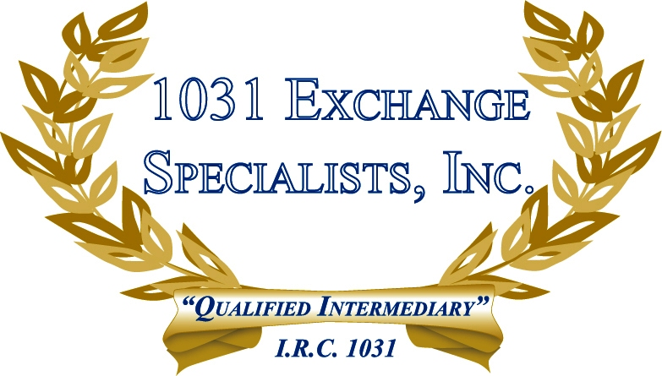

LEASE IN LIEU OF FEE SIMPLE INTEREST: When a fee simple interest in a property, whether partial or whole, creates conflicts with lenders or co-owners, a lease with a remaining life of 30 years or more with options may be an alternative to satisfy the "like-kind" requirement of a 1031 EXCHANGE.

For additional information, please call or email us at:
Local: 609-398-1031 • Toll free: 877-513-1031 info@1031ESI.com

