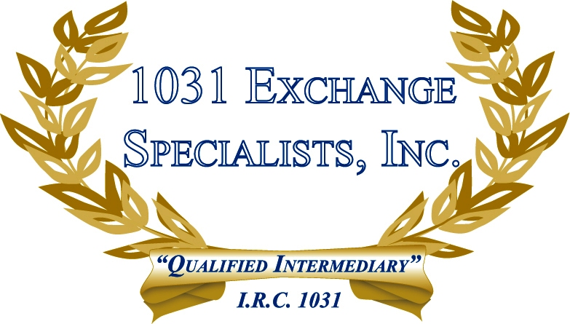

LEGAL ENTITY: When deciding on the best legal entity (LLC, Partnership, C-Corp, S-Corp, Sole Proprietor) for owning property, consider the tax ramifications of spilt-ups, split-offs, dissolution and the availability of a 1031 EXCHANGE.

For additional information, please call or email us at:
Local: 609-398-1031 • Toll free: 877-513-1031 info@1031ESI.com

