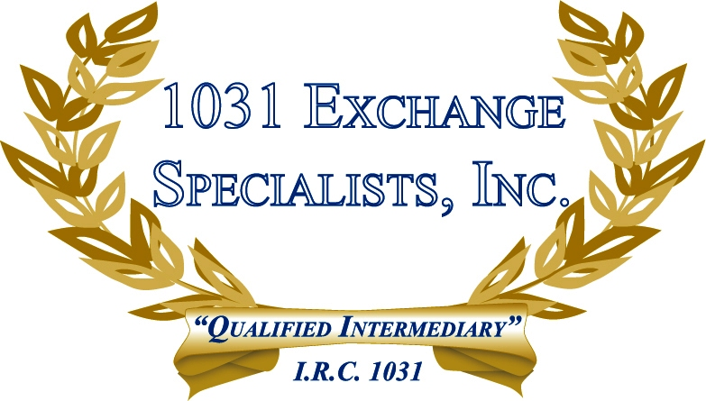

REGULATIONS DO NOT REQUIRE A MINIMUM HOLDING PERIOD: The 1031 EXCHANGE regulations do not require a minimum holding period, however, they do require the property be held for investment or in the productive use of a trade or business, e.g. rental.

For additional information, please call or email us at:
Local: 609-398-1031 • Toll free: 877-513-1031 info@1031ESI.com

