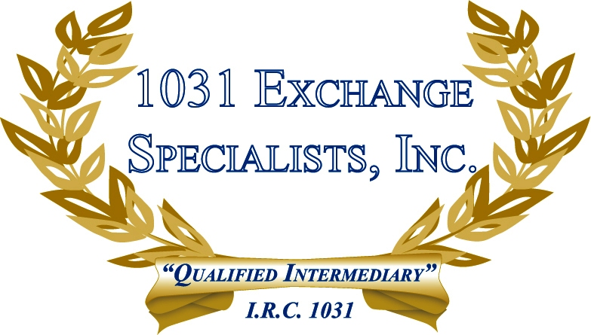

MULTIPLE SINGLE MEMBER LLC's: Multiple single member disregarded entity LLC's, holding title to a property as tenants in common to avoid being classified as a partnership, afford liability protection and is a viable alternative to holding title individually in a 1031 EXCHANGE (state laws may differ).

For additional information, please call or email us at:
Local: 609-398-1031 • Toll free: 877-513-1031 info@1031ESI.com

