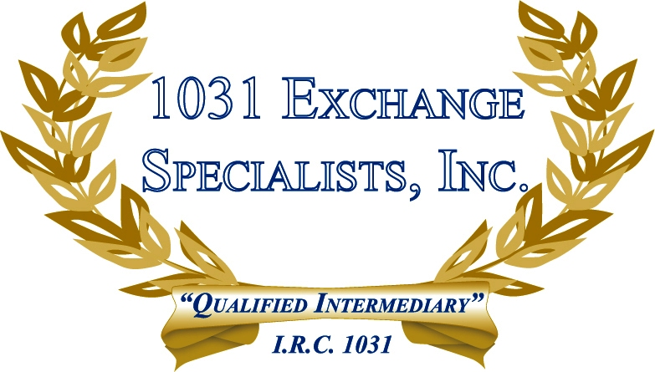

PASSING ON PROPERTY BEFORE OR AFTER DEATH: Passing property to your heirs BEFORE death passes the property at your basis along with the gain and potential tax liability. Passing property to your heirs AFTER death passes the property at fair market value on date of death. A 1031 EXCHANGE can be utilized to eliminate taxable gains generated before or after death.

For additional information, please call or email us at:
Local: 609-398-1031 • Toll free: 877-513-1031 info@1031ESI.com

