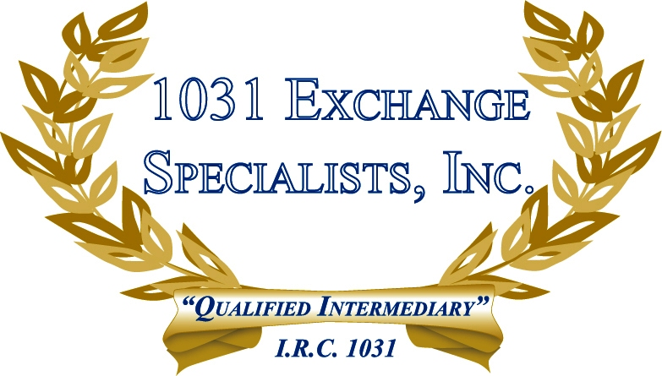

POINTS PAID TO SECURE FINANCING: Points paid to secure a loan in a 1031 EXCHANGE is considered a non-exchange expense as the IRS deems points to be a cost of obtaining a loan and not a cost of acquiring a property. Points paid with 1031 EXCHANGE funds may result in taxable "boot".

For additional information, please call or email us at:
Local: 609-398-1031 • Toll free: 877-513-1031 info@1031ESI.com

