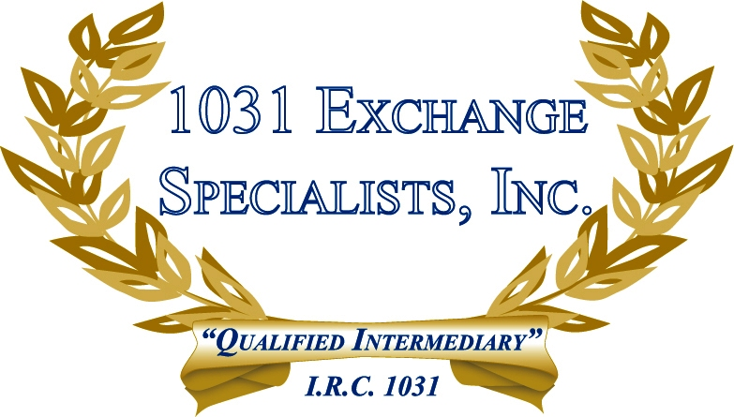

PURCHASING FROM A RELATED PARTY: Generally, purchasing replacement property from a related party in a 1031 EXCHANGE is not permitted, however, recent cases have permitted such transactions where the facts and circumstances show there is no "basis" shifting or intentional avoidance of taxation.

For additional information, please call or email us at:
Local: 609-398-1031 • Toll free: 877-513-1031 info@1031ESI.com

