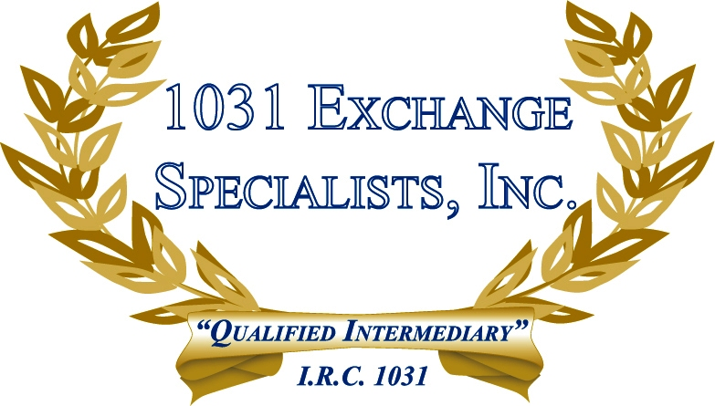

QUALIFYING YOUR PROPERTY FOR 1031 TREATMENT: A property that is not rented and not used more than 14 days per year for pleasure may fall under the definition of "held for investment" and qualify for a 1031 EXCHANGE.

For additional information, please call or email us at:
Local: 609-398-1031 • Toll free: 877-513-1031 info@1031ESI.com

