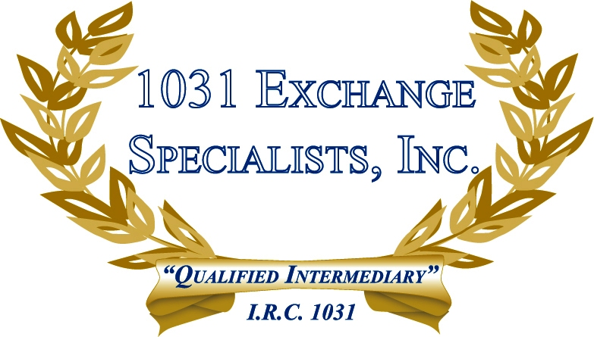

REPLACING MORTGAGE DEBT: The satisfaction of mortgage debt upon the sale of a property in a 1031 EXCHANGE is a taxable benefit to the seller unless replaced with new debt or new cash on the replacement property.

For additional information, please call or email us at:
Local: 609-398-1031 • Toll free: 877-513-1031 info@1031ESI.com

