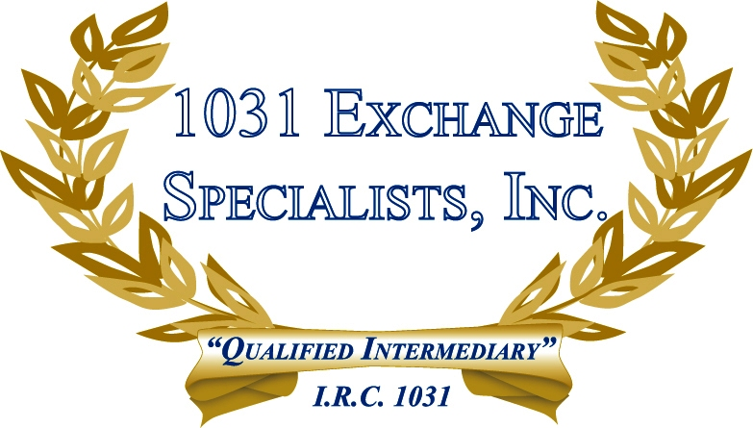

REPLACEMENT PROPERTY LOAN APPLICATION: When applying for a loan to purchase a replacement property in a 1031 EXCHANGE, the taxpayer should: (1) Apply for the loan as an "investment" as the IRS can use the loan application to determine "intent", and (2) Minimize loan acquisition costs as they should not be paid with 1031 funds.

For additional information, please call or email us at:
Local: 609-398-1031 • Toll free: 877-513-1031 info@1031ESI.com

