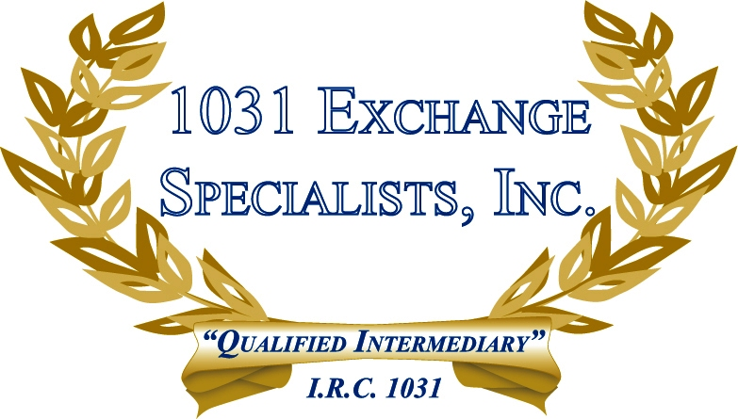

REVERSE EXCHANGE INVESTOR OPPORTUNITY: A REVERSE 1031 EXCHANGE affords an Investor the opportunity to acquire a new property at a bargain price AND enjoy the concurrent use and rental incomes of both the old and new properties for up to 6 months.

For additional information, please call or email us at:
Local: 609-398-1031 • Toll free: 877-513-1031 info@1031ESI.com

