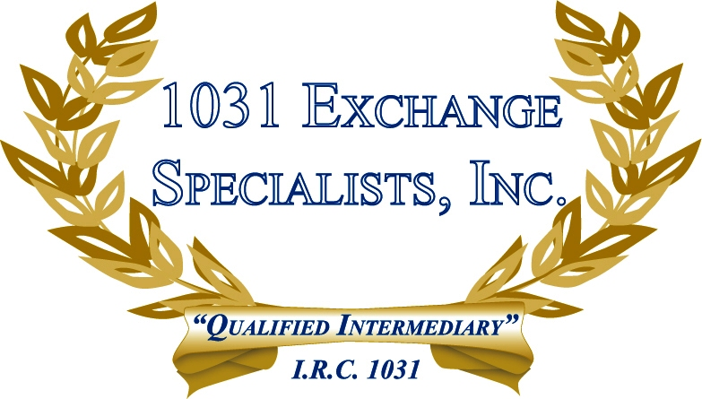

SAME TAXPAYER REQUIREMENT - SPOUSE: Investment property held individually by a spouse in a non-community property State must maintain its separate ownership upon acquisition of replacement property in a 1031 EXCHANGE. The non-exchanging spouse may take ownership of any interest in excess of the exchanging property's interest.

For additional information, please call or email us at:
Local: 609-398-1031 • Toll free: 877-513-1031 info@1031ESI.com

