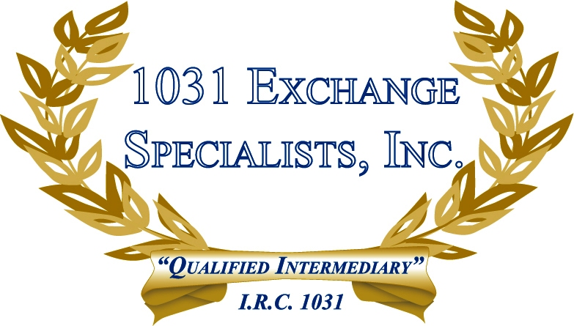

SELLING MULTI-UNIT PROPERTIES: When selling a multi-unit property with both personal/vacation use and investment use, taxes can be avoided on the investment units by utilizing a 1031 EXCHANGE.

For additional information, please call or email us at:
Local: 609-398-1031 • Toll free: 877-513-1031 info@1031ESI.com

