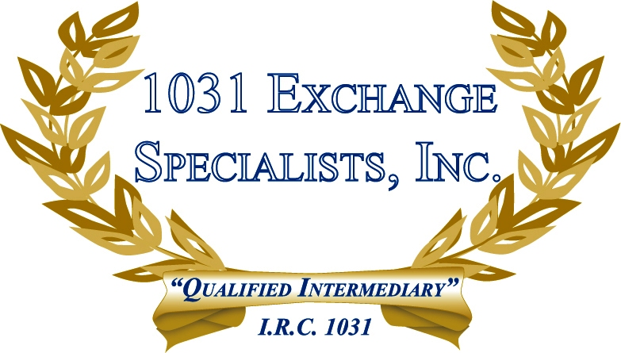

TAX REPORTING & DEED INCONSISTENCIES: Often, a property owner will transfer a property to another legal entity, such as a LLC, Partnership, Trust, or Corporation, for tax purposes but fail to make the necessary changes to the deed. When the property is sold, the 1099-S will be issued under the deeded ownership, causing an inconsistency with the tax reporting. This can be fatal to a 1031 EXCHANGE.

For additional information, please call or email us at:
Local: 609-398-1031 • Toll free: 877-513-1031 info@1031ESI.com

