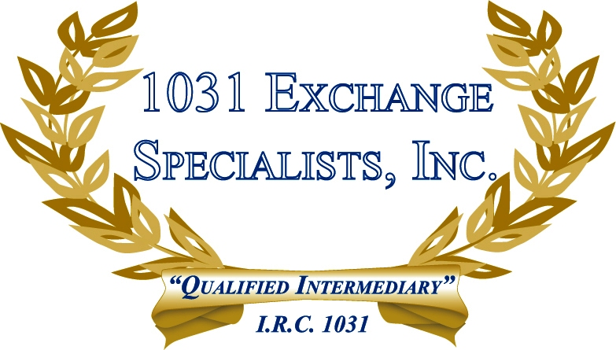

TAX TREATMENT FOR INVESTMENT PROPERTY: Property held for investment more than 1 year receives capital gains treatment upon sale. Property held 1 year or less is subject to ordinary income tax upon sale. Property held primarily for sale to customers in the ordinary course of business is considered "inventory" and is subject to ordinary income taxes upon sale regardless of the length of time held.

For additional information, please call or email us at:
Local: 609-398-1031 • Toll free: 877-513-1031 info@1031ESI.com

