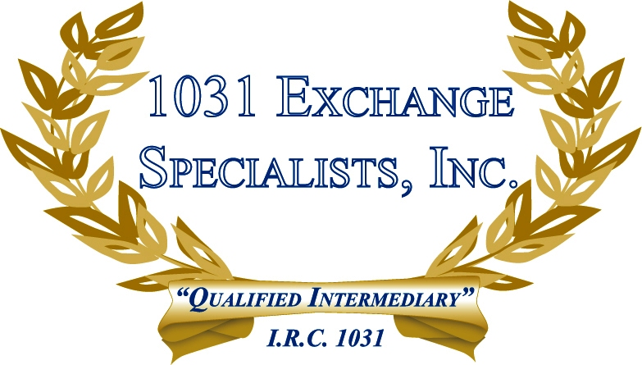

TENANCY IN COMMON: In 2002, the IRS issued Revenue Procedure 2002-22 containing 15 guidelines for Tenancy in Common ownership of property in a 1031 EXCHANGE. The 15 guidelines help to distinguish a co-tenancy versus a partnership ownership.

For additional information, please call or email us at:
Local: 609-398-1031 • Toll free: 877-513-1031 info@1031ESI.com

