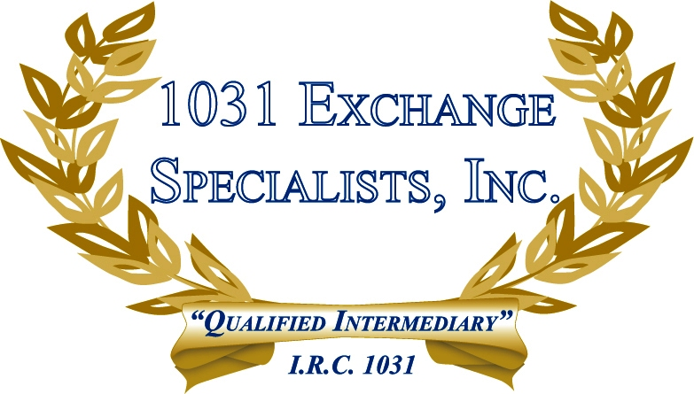

TRANSFERRING OWNERSHIP TO A RELATED PARTY: The tax implications of passing title on an investment property to a related party vary depending on the vehicle utilized...i.e. 1031 Exchange; Installment Sale; Gift; Inheritance; Life Estate; Sale; or a combination of all of the above. Review each option carefully.

For additional information, please call or email us at:
Local: 609-398-1031 • Toll free: 877-513-1031 info@1031ESI.com

