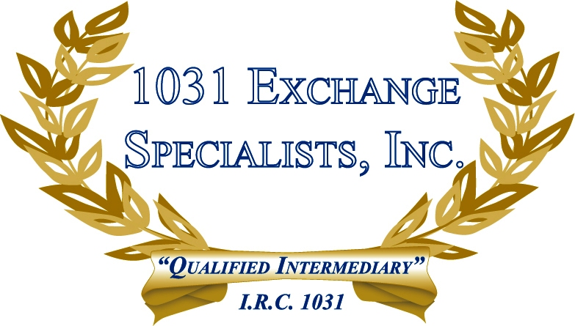

TRANSFER OF MEMBERSHIP INTEREST: The transfer of a membership interest in a single member disregarded entity LLC may or may not be taxed at the state level depending on individual state law.

For additional information, please call or email us at:
Local: 609-398-1031 • Toll free: 877-513-1031 info@1031ESI.com

