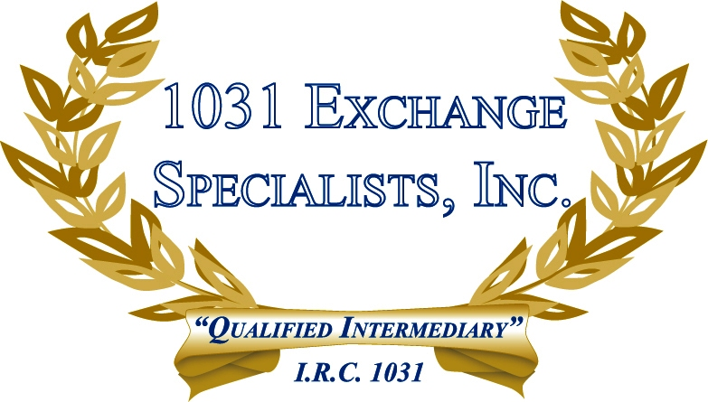

TRANSFER TAX IMPLICATIONS - BUILD TO SUIT/REVERSE: In a REVERSE and BUILD-TO-SUIT1031 EXCHANGE using an Exchange Accommodation Titleholder (EAT), the EAT has to acquire the full benefits and burdens of the relinquished or replacement property, resulting in a second ownership transfer, and potentially a second real estate transfer tax upon final transfer depending on the State and the method of ownership transfer.

For additional information, please call or email us at:
Local: 609-398-1031 • Toll free: 877-513-1031 info@1031ESI.com

