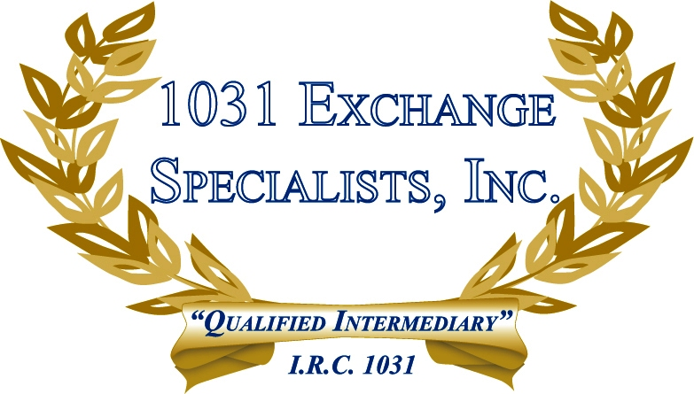

TREATMENT OF INTEREST: In a 1031 EXCHANGE, interest earned on exchange funds of $2 million or less and held for 6 months or less is not subject to special allocation rules.

For additional information, please call or email us at:
Local: 609-398-1031 • Toll free: 877-513-1031 info@1031ESI.com

