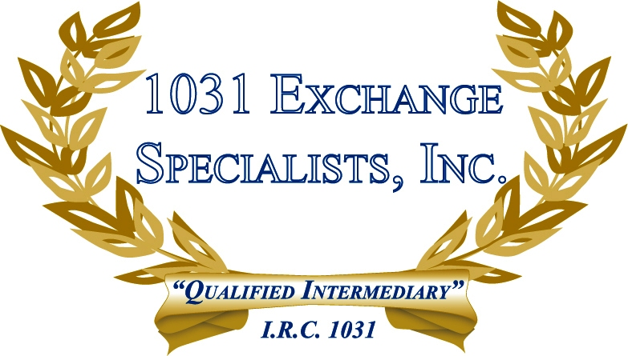

VACATION/INVESTMENT HOME CONVERSION: Property converted from Vacation/Investment use to Primary Home after December 31, 2008 will require the allocation of gain to "Non-qualified" and "Qualified" periods, whereby the primary home exclusion of $250/500K can only be applied to the "Qualified" period. Read more about this topic on our "Mixed Use Property" page.

For additional information, please call or email us at:
Local: 609-398-1031 • Toll free: 877-513-1031 info@1031ESI.com

