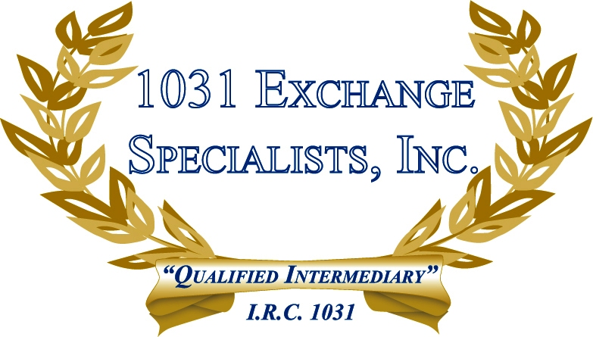

WATER RIGHTS: Perpetual water rights, regardless of the quantity of water, have been ruled by the IRS to be "like-kind" to a fee interest in real estate and, therefore, afforded 1031 EXCHANGE treatment.

For additional information, please call or email us at:
Local: 609-398-1031 • Toll free: 877-513-1031 info@1031ESI.com

